**American International University- Bangladesh**

**Department of Electrical and Electronic Engineering**

**Title: Study of Analog to Analog Conversion (QAM) using MATLAB Simulink**

**Abstract:**

This experiment is designed to-

1. To understand the use of MATLAB for solving communication engineering problems.

2.To develop understanding of QAM, Constellation diagram and Finding Bit Error rate

**Introduction:**

PSK is limited by the ability of the equipment to distinguish small differences in phase. This factor limits its potential bit rate. The idea of using two carriers, one in-phase and the other quadrature, with different amplitude levels for each carrier is the concept behind **quadrature** **amplitude modulation (QAM).**

**Quadrature amplitude modulation is a combination of ASK and PSK.**

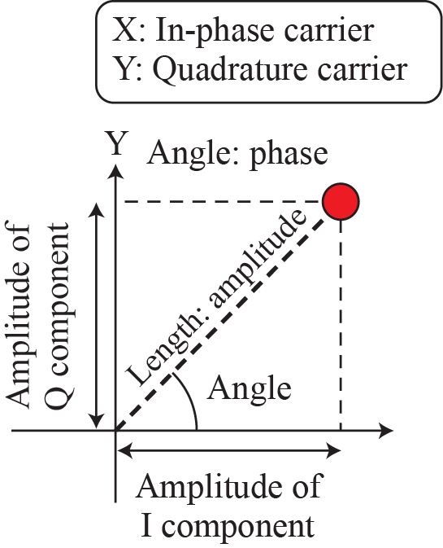

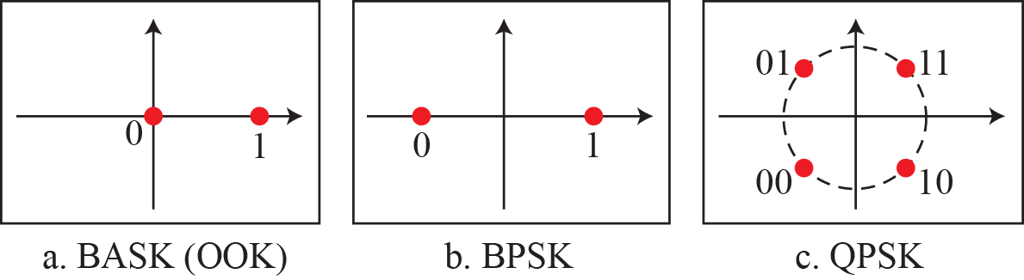

Figure 1: ***Concept of a constellation diagram***

The possible variations of QAM are numerous. Figure shows some of these schemes. Figure (a) shows the simplest 4-QAM scheme (four different signal element types) using a unipolar NRZ signal to modulate each carrier. This is the same mechanism we used for ASK (OOK). Part b shows another 4-QAM using polar NRZ, but this is exactly the same as QPSK. Part c shows another QAM-4 in which we used a signal with two positive levels to modulate each of the two carriers. Finally, Figure (d) shows a 16-QAM constellation of a signal with eight levels, four positive and four negative.

The minimum bandwidth required for QAM transmission is the same as that required for ASK and PSK transmission. QAM has the same advantages as PSK over ASK.

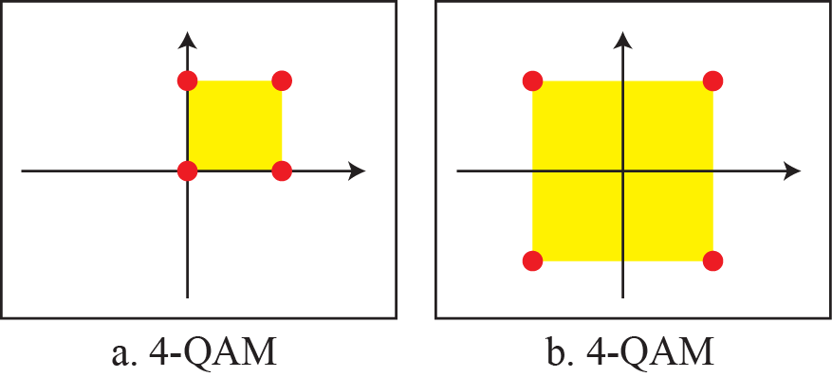

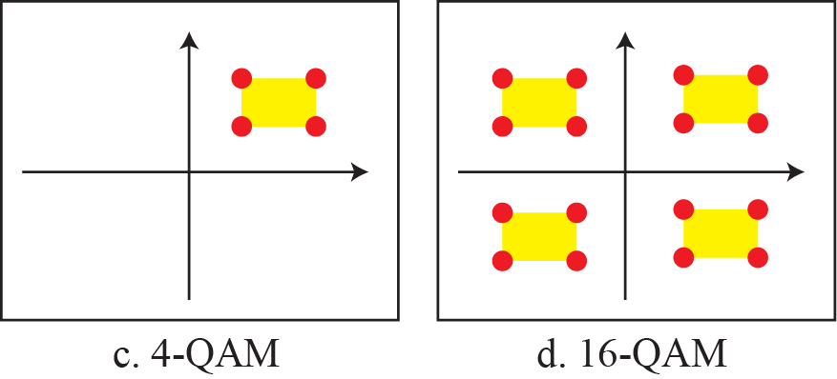

Figure 2: Constellation Diagram of QAM

The demodulator maps the received signal (possibly distorted due to noise in the channel) back to bit streams.

For 16 QAM, the Bit Error Rate (BER) is the same as BPSK.

BER= $\frac{3}{4}$ Q ($\sqrt{\frac{4Eb}{No}}$

Since in QAM modulation two carriers are used, the Symbol Error Rate per carrier is given by:

Psc= $\frac{6}{4}$ Q ($\sqrt{\frac{Es}{5No}}$

And the total Symbol Error Rate is given by:

Ps = 1 – ${(1-PsC)}^{2}$

Where N0/2 is the noise power spectral density, and Q(.) is the Q function of the Gaussian distribution.

**Simulink Model:**

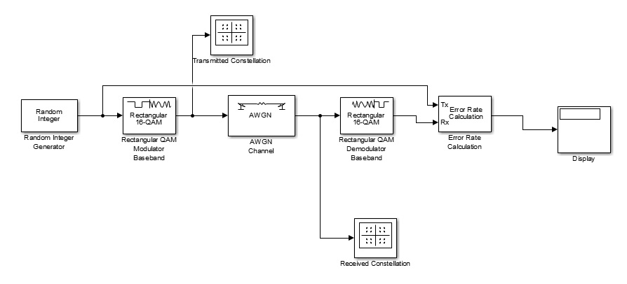

Figure: 16-QAM Simulation Model

* Build the Simulink model shown in Figure 3.
* Double-click on the Random Integer Generator and adjust the set size to 16
* In the Random Integer Generator block, set the Sample Time to 2e-6 (i.e. 2 µs) and the Samples per frame parameter to 1024.
* In the AWGN block, set the Symbol period parameter to 2e-6 (i.e. 2 µs) and the Number of bits per symbol parameter to 4 (since 16 QAM uses 4 bits per symbol).
* For the Error Rate Calculation block, set the Output data field to “port” so you can connect the Display block.
* Set the simulation time to 10 seconds.
* In both 16 QAM Modulator and Demodulator blocks, set the Constellation ordering to Gray, set the Normalization method to Peak Power, and set the value of the Peak power to 1 Watt.
* In this experiment, you will adjust the value of the E_b/N_0 in the AWGN block, starting from 5, incrementing by 1 every step, and ending at 10, and observe the error rate displayed in the Display block. Make a table recording the value of E_b/N_0 and the corresponding BER.
* Plot BER vs. E_b/N_0 and compare with the theoretical values. Comment on the results.
* Repeat for different values of the Peak power and plot the results.

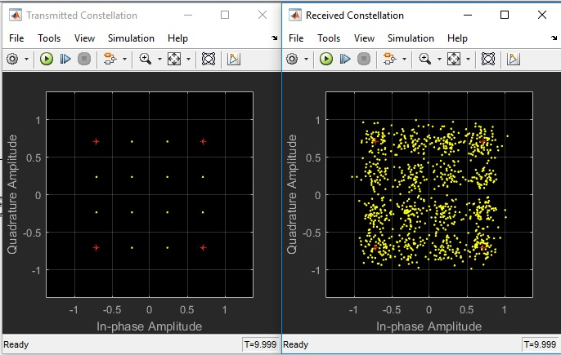

Figure 4: Output of Transmitted and Received Constellation Diagram

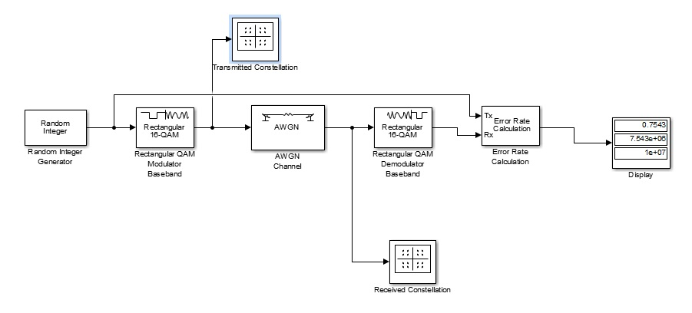

Figure 5: Bit Error rate QAM

The Display Block will show you three values. The first value is the BER, the second value is the number of incorrect bits, and the third value is the total number of bits received.

**Reference**

1. Forouzan, B. A. "Data Communication and Networking. Tata McGraw." (2005).
2. M. P. Fitz, Fundamentals of Communications Systems, pp. 7.1-7.7, 2007, McGraw-Hill
3. MathWorks®